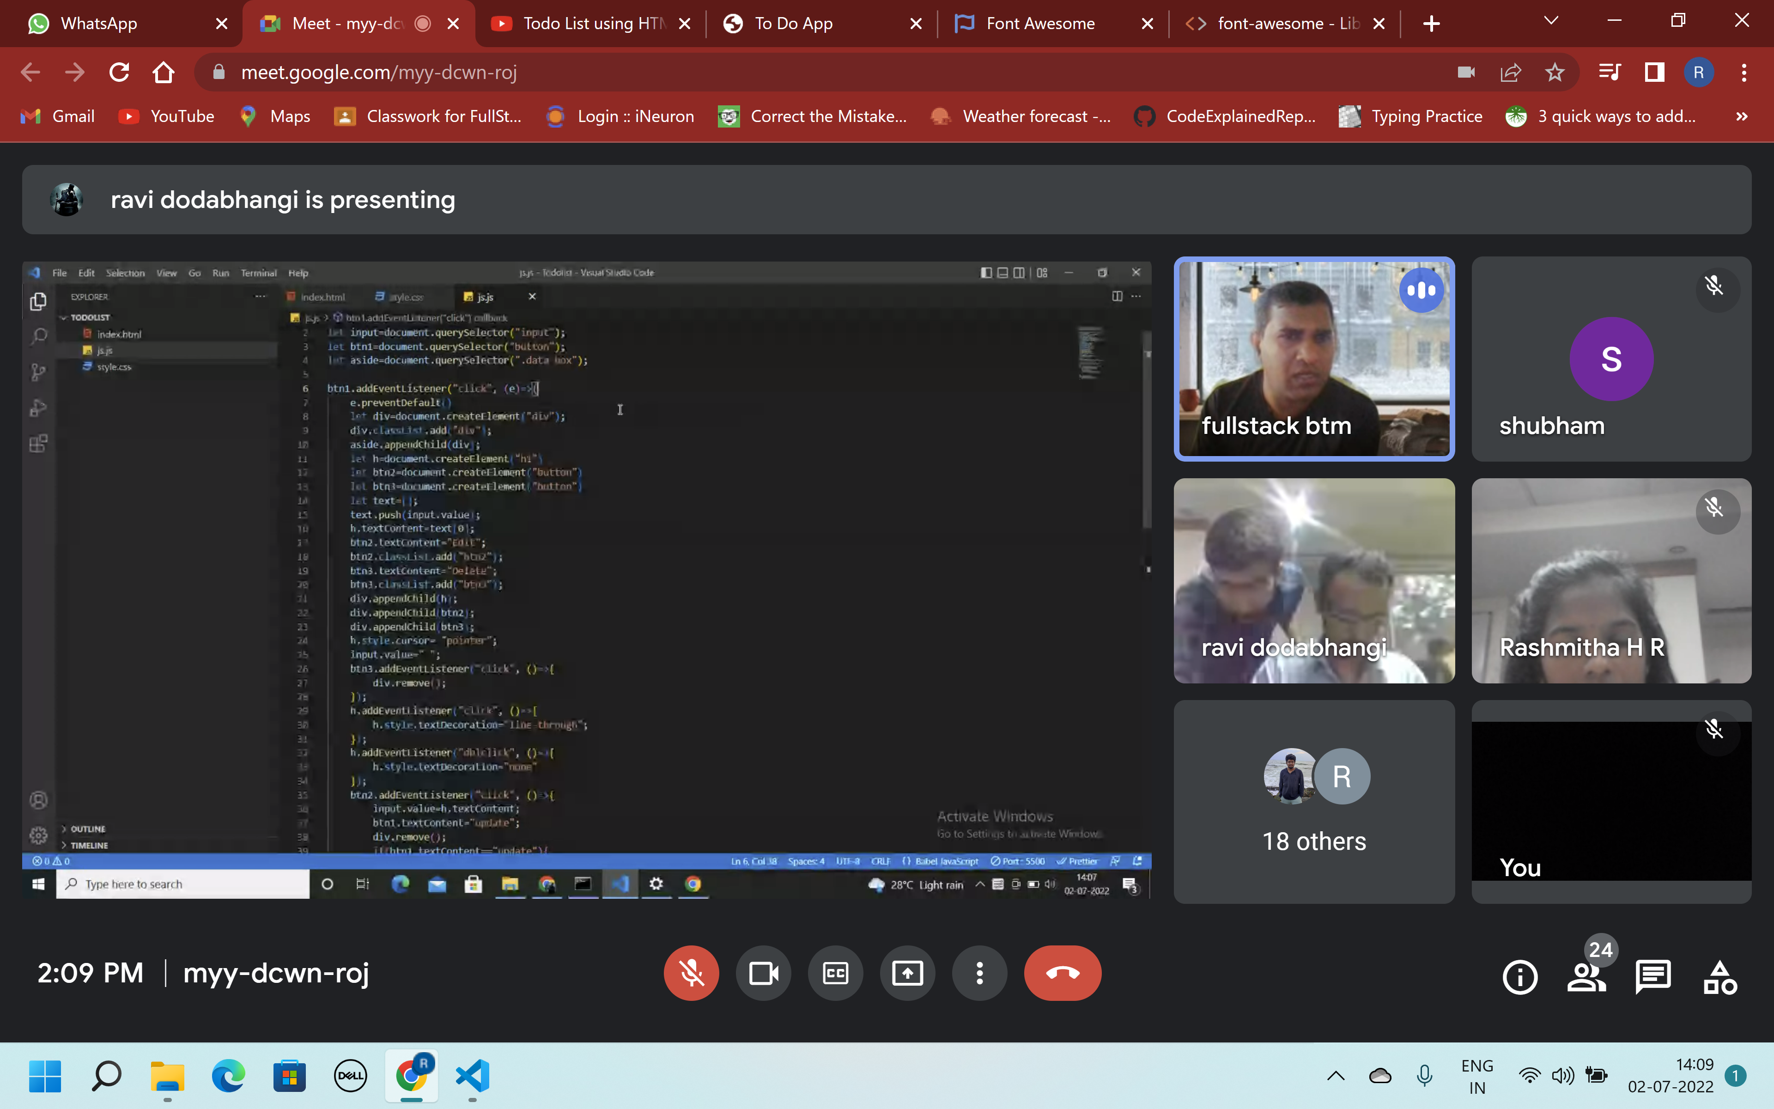

Hi this is sthe change I made to the file